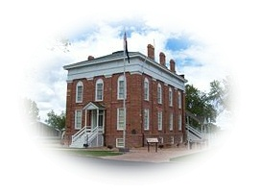
Fillmore City Cemetery
“Silent City”

75 West Center Street
Fillmore, Utah 84631
Utah’s First Capital (435) 743-5233

TRANSFER OF BURIAL RIGHTS
FILLMORE CITY CEMETERY
Regarding: Block ______________
Lot ______________
Graves ______________
The burial rights at the above location owned by:
_______________________________________________________________
are hereby transferred to:
Owner: ______________________________________________________________________
Address: ______________________________________________________________________
Phone: ______________________________________________________________________
Email: ______________________________________________________________________

Signed: __________________________________________________ Date:__________________________

Address:___________________________________________________ Phone: ________________________

Subscribed and sworn to before me this __________________ (date) by________________________________________
(Seal) ___________________________________
Notary Public
My Commission Expires: ______________

